**MAT188 – Lab #4**

**Penicillin Clearance**

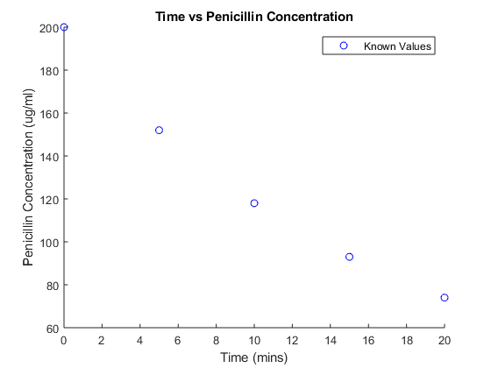

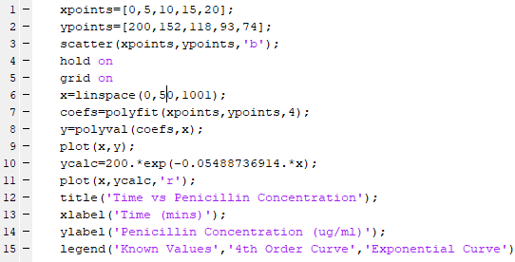

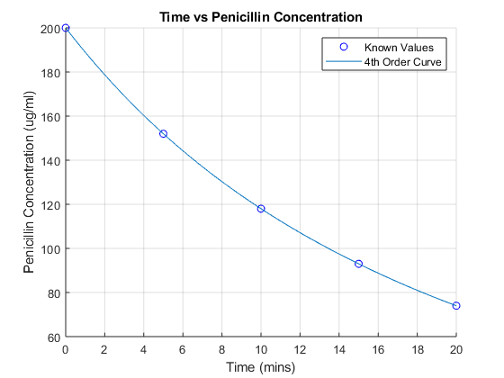

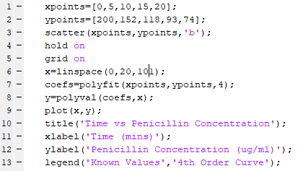

1. This is the process I used to determine an equation for an exponential fit using 2 data points

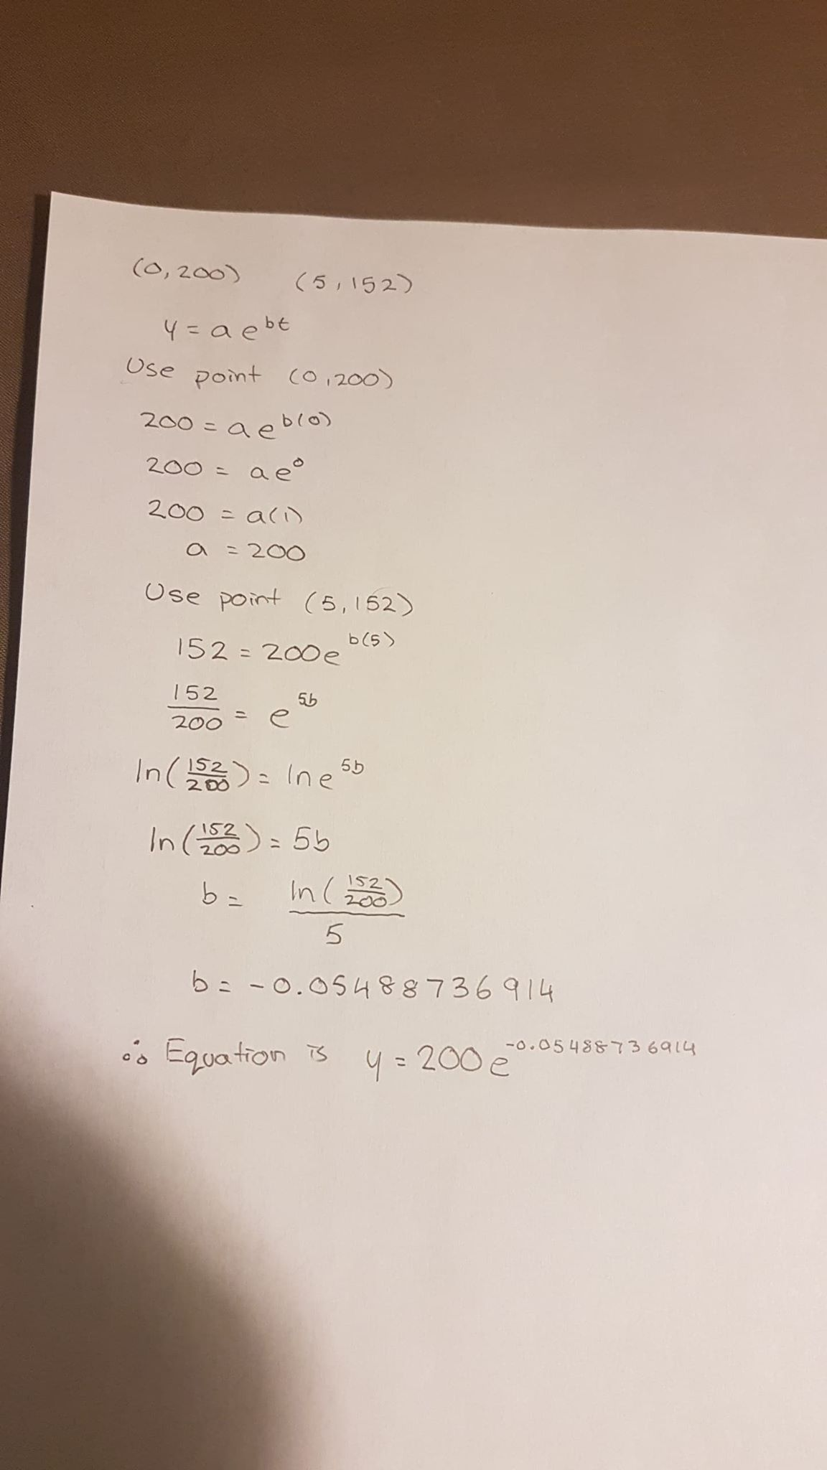

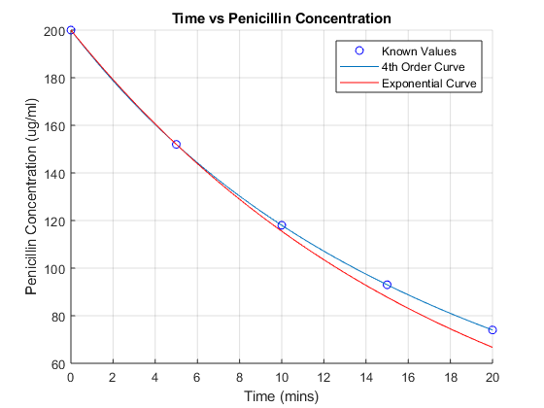

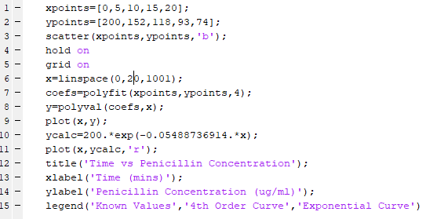

1. After increasing the domain for both graphs, the exponential fit is a better model of the real-life situation as the concentration continues to decrease over time whereas the 4th order curve increases later. Although the exponential fit does not pass through all the given known values, it is a much more accurate representation of how the concentration would deplete over time.

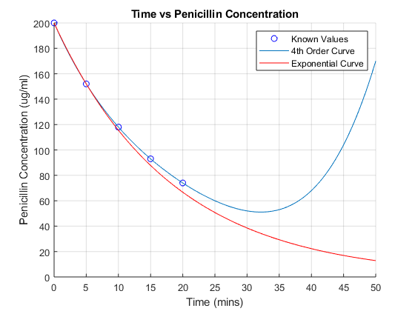

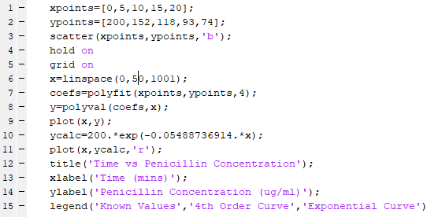

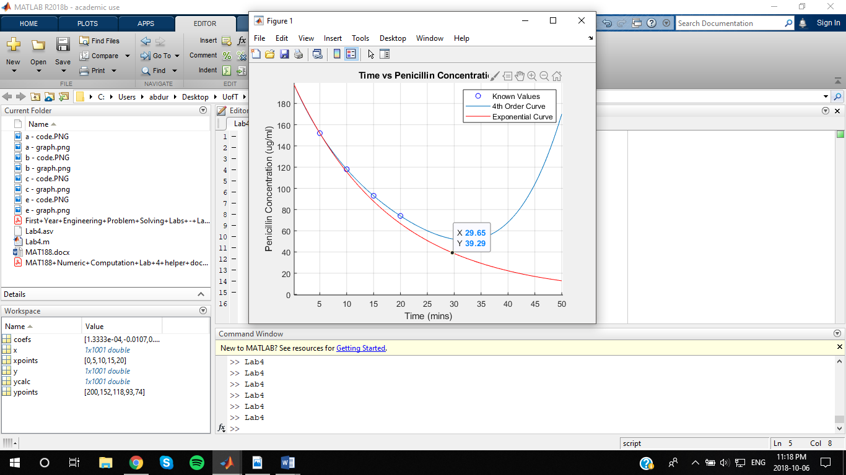

Based off the exponential curve, the penicillin concentration would drop below 40μg/ml after about 30 mins.

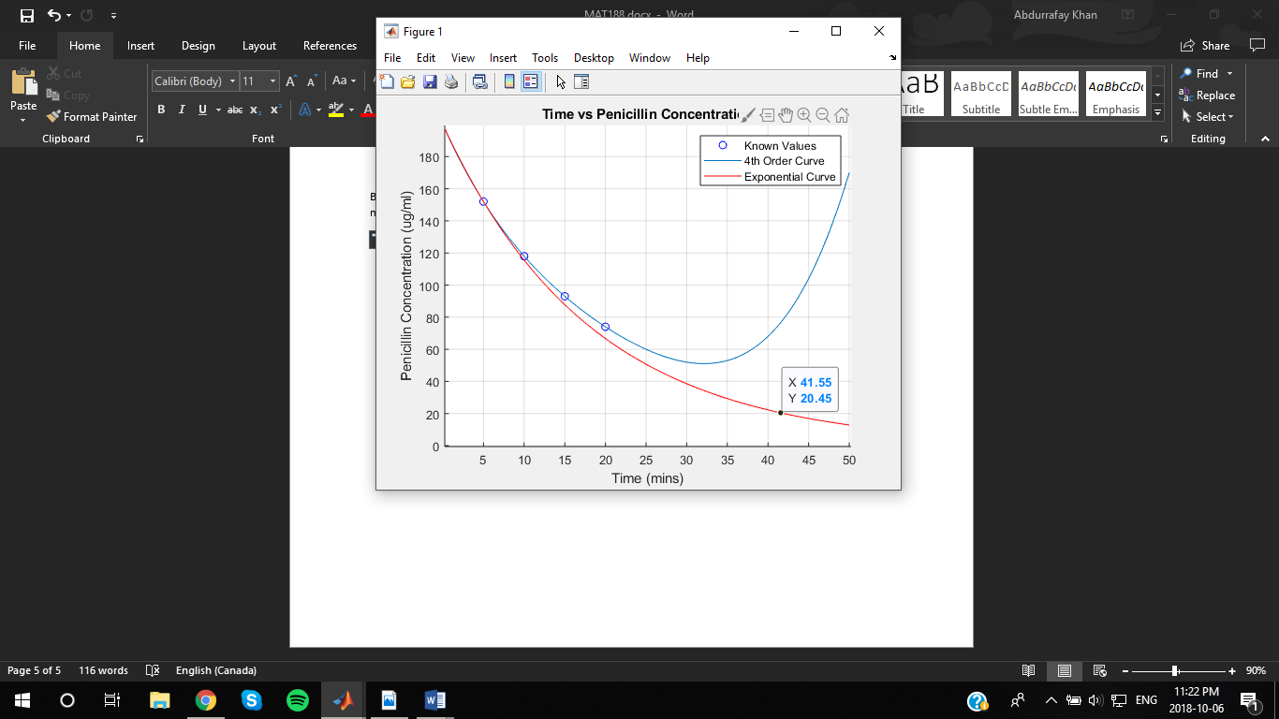

Based off the exponential curve, one should wait about 42 minutes at the longest before getting penicillin injections.

1. MatLab is a useful computational tool that helped with solving the given Penicillin question as a part of this Lab. It was useful to be able to create various degree order functions using just 5 points of data. Changing the order of the graphs helped in creating one curve that was accurate compared to the rest. With MatLab’s ability to plot graphs on the same axes, it was easy to compare and determine which graph is more accurate to the real-life model. Being able to change the domain of the plot also helped in choosing a more accurate representation of data. This lab really showed how MatLab can be used to create functions given points, plot different functions and be able to effectively analyze them to answer any questions about them.